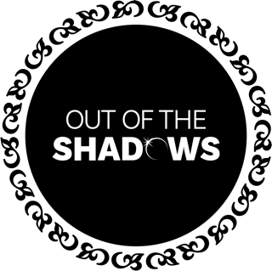

Out of the Shadows Choir
MOBILE PHONE POLICY

As part of our commitment to keeping children safe, Out of the Shadows have adopted this Mobile Phone Policy.
Whilst we recognise that mobile phones are an integral part of everyday life, we also understand that they can easily become a platform for bullying, distress, and unwanted photographs and videos.
Therefore, mobile phone use is not permitted within our youth classes by any participant or observer, unless by prior agreement or in exceptional circumstances.
The choir leader and assistant in the room are permitted to use their phones for music purposes, photographs and videos for uses agreed in the choir membership form/Media Policy, and in emergency contact situations.
Our adult groups are free to use their mobile phones, but we do ask that they are mindful of use if in the presence of our youth groups. This includes playing music or videos that contain swearing or adult themes.
Adult choir members are not permitted to take photographs or videos of youth choir members.

We are committed to reviewing our policies annually.
This policy was last reviewed on 8th March 2026.
Signed:
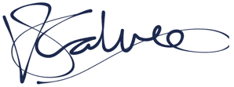
Victoria Calver, DSO

