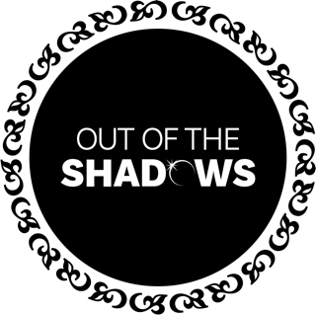

Out of the Shadows
MEDIA POLICY

Adult Only Groups
As a performing group, all members of Out of the Shadows choir should be prepared that they may have their photograph taken or appear as part of a video taken or shared by members of the public.
Within a rehearsal setting, pictures or videos may be taken for rehearsal purposes. These may be shared within the group but will not be shared further without prior notice.
Occasionally, Out of the Shadows may take videos or photos in rehearsals or at performances for promotional purposes. This will be agreed with all parties in advance, and participants will have the option to opt out.
If there are any concerns about photographs or videos, please speak to Victoria Calver or Lauren Mawdsley, both of whom can be contacted at admin@choiroutoftheshadows.com.

Youth Groups
It is expected that our youth group may have photographs or videos taken and shared as part of their concert. By signing up to Out of the Shadows, parents or guardians accept this as part of being in a performing group.
In a rehearsal setting, photos or videos will only be taken for rehearsal purposes by a nominated adult and will not be shared beyond the choir leader. Photos and videos will be deleted once their purpose has been served, or after 6 months, whichever is sooner.
Occasionally, Out of the Shadows may take videos or photos in rehearsals or at performances for promotional purposes. This will be agreed with all parties in advance, and participants and their parents or guardians will have the option to opt out.

If a parent or guardian has any concerns about photos or videos, please contact Victoria Calver or Lauren Mawdsley at admin@choiroutoftheshadows.com.

We are committed to reviewing our policies annually.
This policy was last reviewed on 8th March 2026.
Signed:
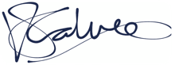
Victoria Calver, DSO

