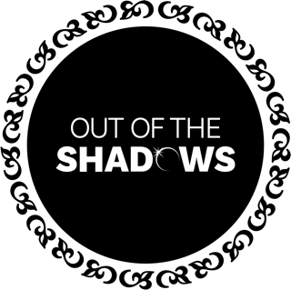

Out of the Shadows Choir
SAFEGUARDING CODE OF CONDUCT FOR ADULTS

Out of the Shadows Choir has a responsibility to the children and young people who use its services. As an organisation, we prioritise the welfare and safety of our young members. Everyone has a duty to report safeguarding concerns, and we ask all adults affiliated with our choirs* to follow the below code of conduct:
- Children and young people first
- It is much better to say something and be wrong than say nothing
- It is everyone’s responsibility to keep children safe
- If in doubt, report it
If an adult within any of our groups has any concerns, please speak to Victoria Calver (DSO) or Lauren Mawdsley (Administrator).
*This includes all staff (including freelancers and volunteers), all adult members of our choirs, helpers, administrators and chaperones.

We are committed to reviewing our policies annually.
This policy was last reviewed on 8th March 2026.
Signed:
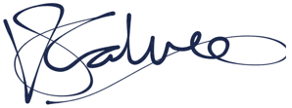
Victoria Calver, DSO

